

***SPRINTEST***TM CBF-Java User Installation Manual



Table of Contents

Table of Contents

1. Installation Manual 3

1.1 Eclipse settings 3

1.2 Setup Framework 3

2. Execution and Reporting 8

2.1 How to execute via Eclipse 8

2.2 How to perform unattended execution via ANT file 10

2.3 Execution Results 12

2.4 Troubleshooting and debugging 13

2.5 Steps to generate Javadoc 13

3. DevelopmentManual 14

3.1 API user guide 14

3.2 Methodology &process 14

3.3 Debugging & troubleshooting 14

4. Maintenance Manual 14

4.1 Framework testing, debugging and troubleshooting 14

# Installation Manual

## Eclipse settings

* Java must be installed into the system to work with Eclipse.
* Java version must be compatible with the Eclipse version to be used.
* Libraries to be added should be present at the accessible locations.

## Setup Framework

Steps to setup project in workspace using framework libraries

**Step 1:** Click on File->New->Java Project menu item

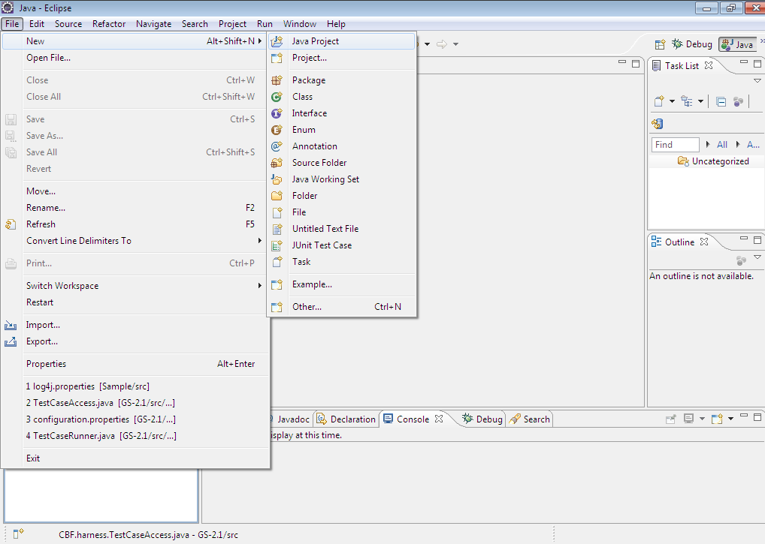

**Step 2**: Provide project name and select create new project in workspace.

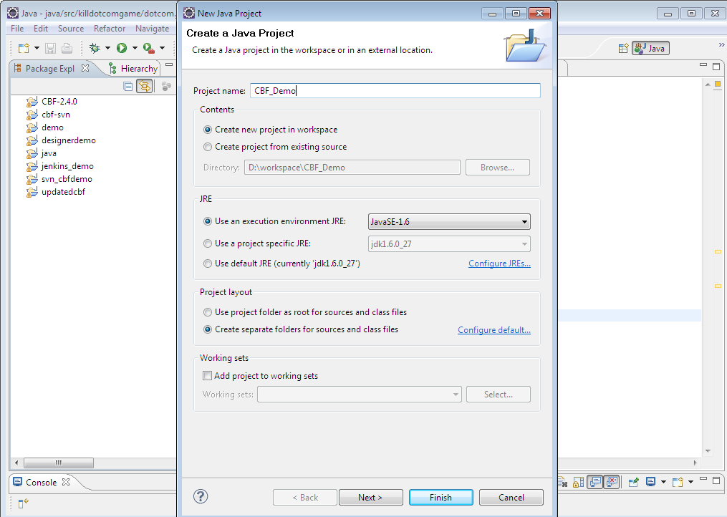

Click on Finish button.

In case of creating project from existing source, provide the path of the folder where you want to keep the project.

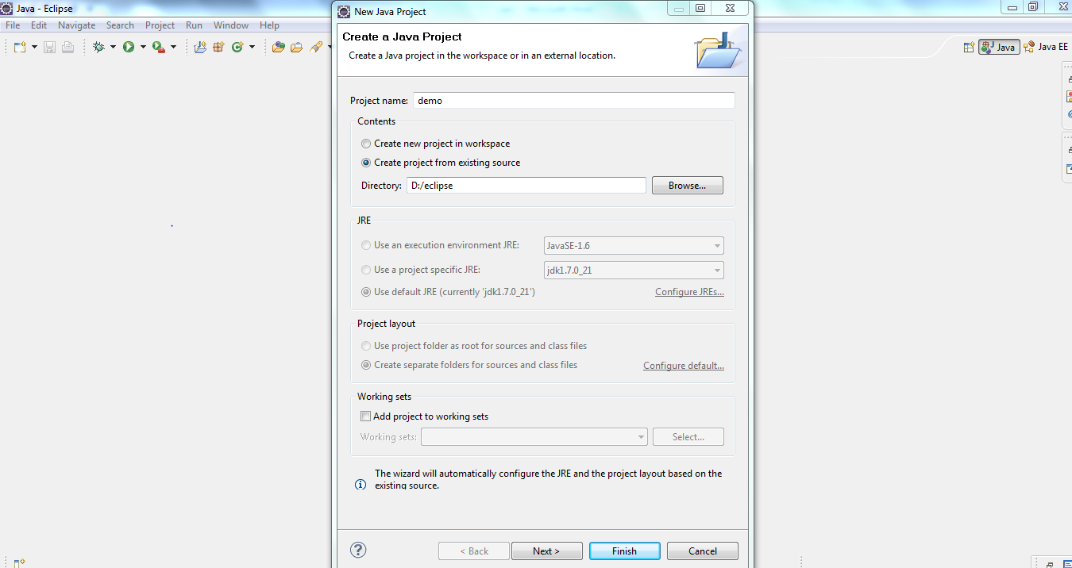

Click on Finish button, the project gets added. 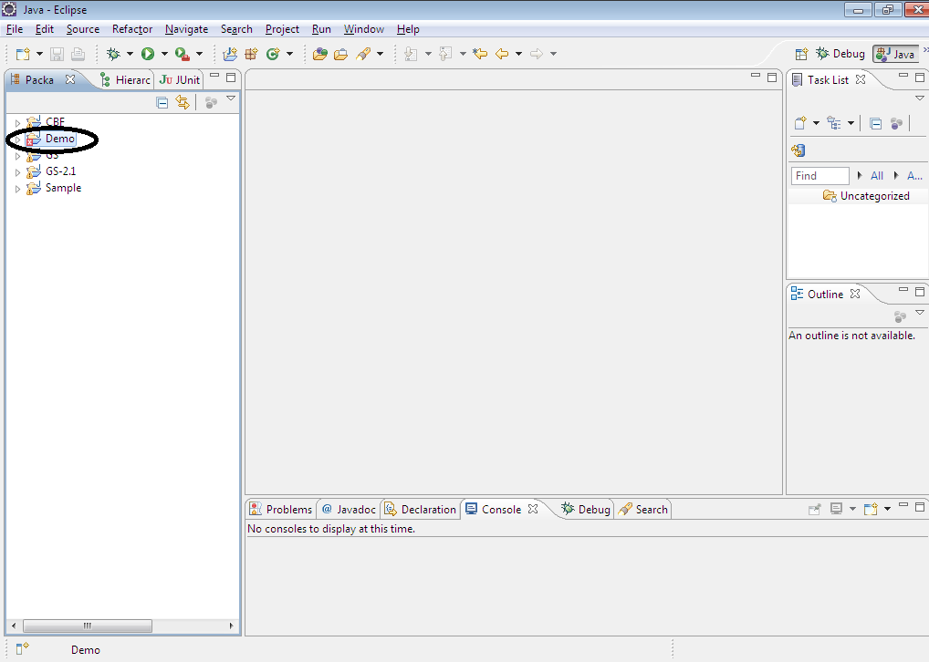

**Step 3 :** To associate external jars, right click on the added project, go to Build Path

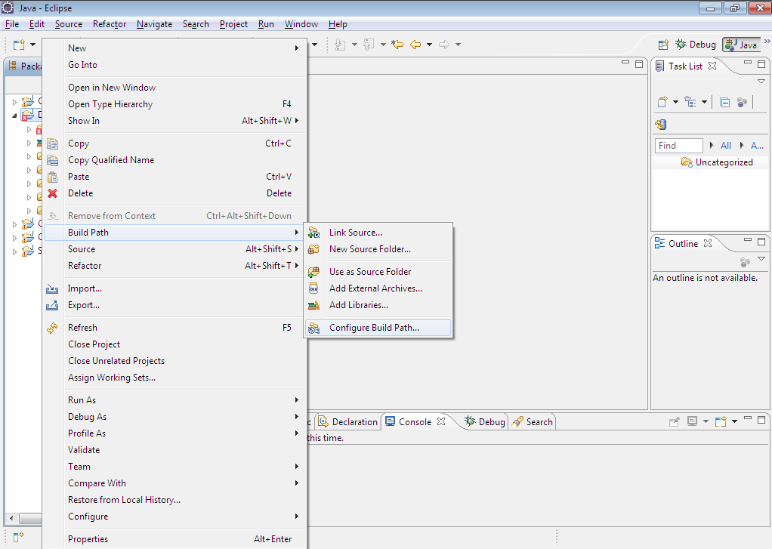

Select Configure Build Path, Java Build Path window comes up.

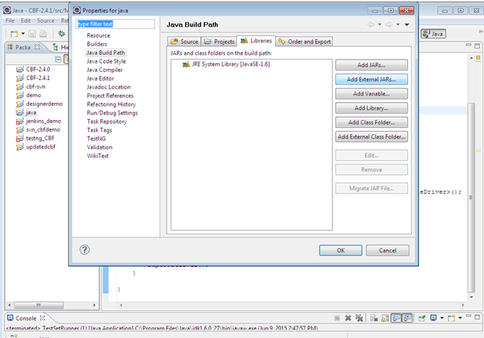

Click on Add External JARs button, locate the folder where jar files are saved, select the necessary jars for association

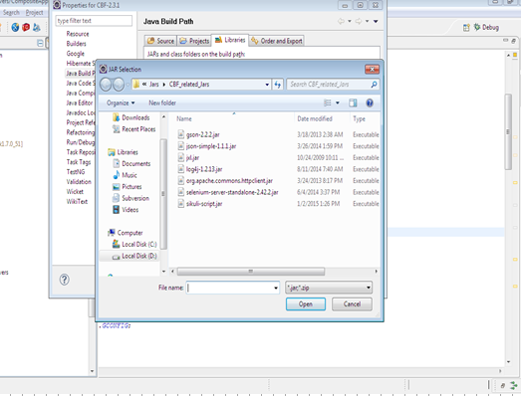

Click on Open button, so that the selected jars gets associated.

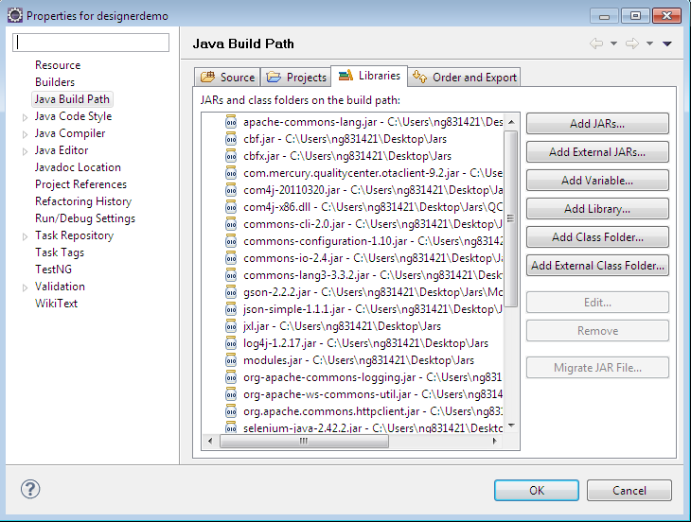

Click on OK button to close the Java Build Path window.

**Step4** : Copy “**ModuleDrivers**” folder from **Test\Plan\AppDriver**and paste it inside “**src**” folder.

After that **src** folder structure will be like :

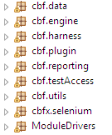

# Execution and Reporting

## How to execute via Eclipse

**Step 1**:Open the Test Set.xls file from Lab folder.

**Step 2:** Update the SelectYNcolum value to Yes|Y|yes. Select the test cases to be executed from the existing Test Set.

**Step 3** : Go to **Run** taband click on run configurations.

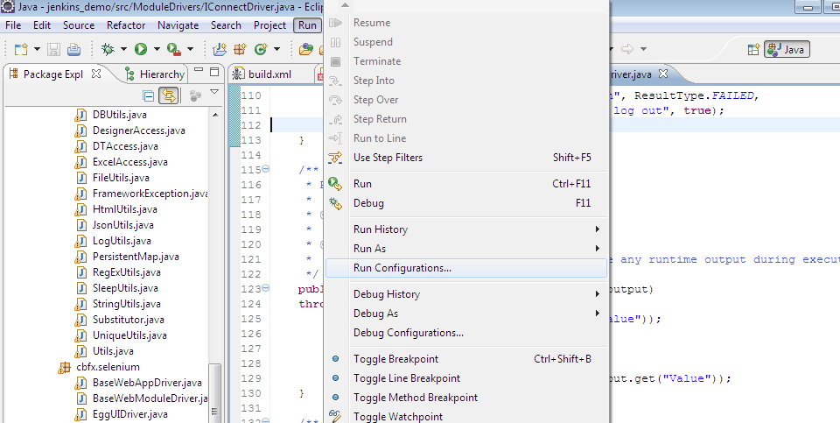

**Step 4:** A dialog box will open as shown below. In the “main” tab, click on the “Browse” button to select the project.

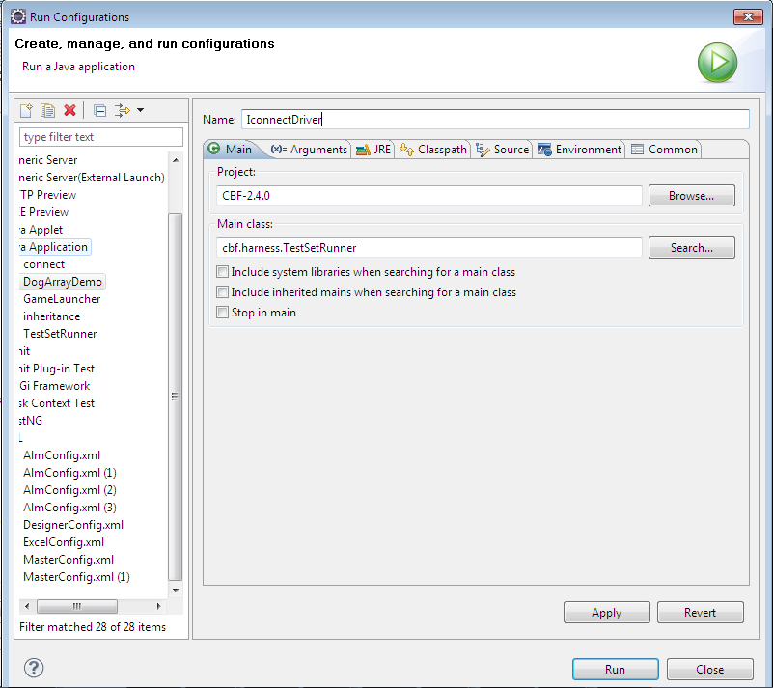

**Step 4:** A dialog box containing the projects will open.Select the required project and click on OK button.

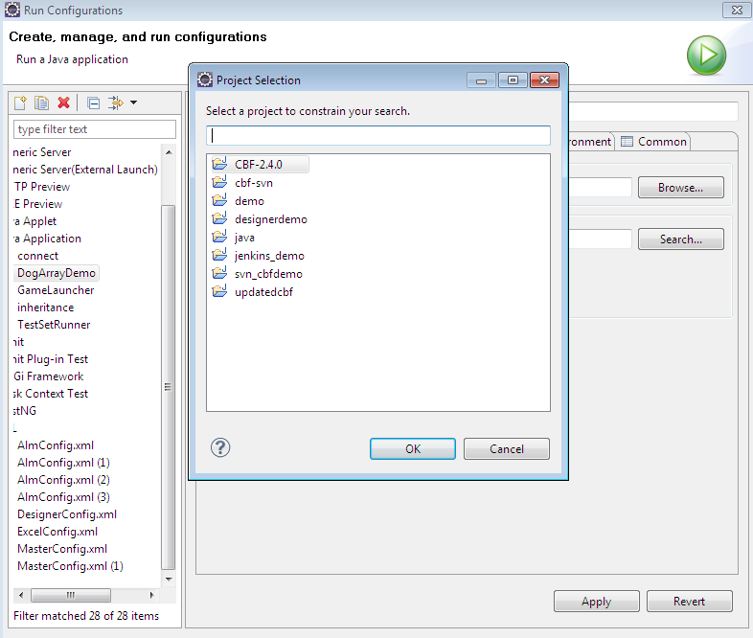

**Step 5:** Click on search button in main tab and select TestSetRunner and click OK button.

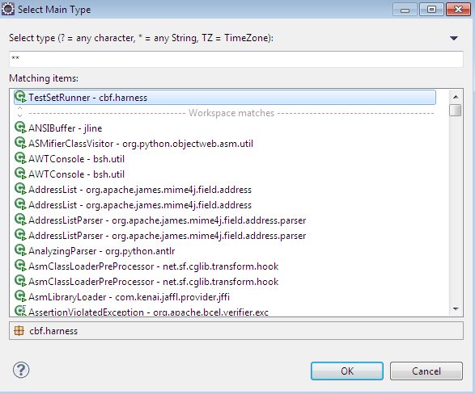

**Step 6:** Click on “Arguments” tab and give the required parameters and click on Run button.

The syntax to provide the parameters is –< argument name> <argument_value>.

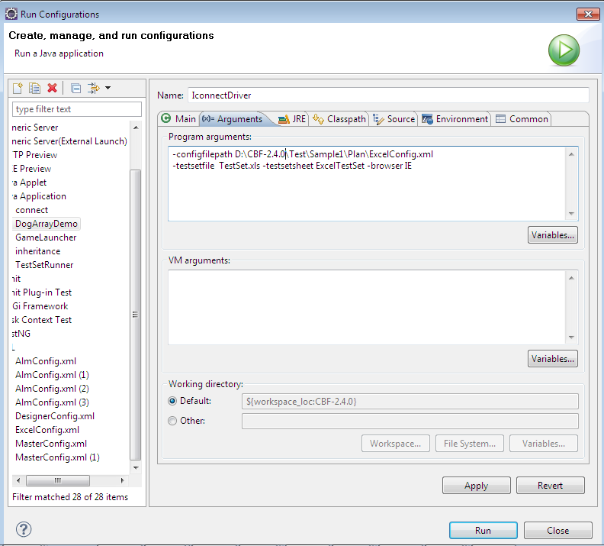

## How to perform unattended execution via ANT file

**Step 1: Create** a folder for the CBF setup on your system.

**Step 2: Copy** ModuleDrivers from project setup and paste it inside cbf folder in project folder created..

**Step 3: Copy** all the jars required into the **lib** folder including the framework jar(**cbf.jar-**having all the cbf classes except ModuleDrivers and the **cbfx.jar** havingui package files).

**Step 4**: Copy **log4j.properties**, **MasterConfig.xml** and **ReportTemplate.xls** files inside the **Resources** folder**.**

**Step 5: Copy** the complete **Test** folder directly inside the project folder.

**Step 6: Create** **build.xml** file that we can directly execute from ANT. Give the references of all the jars required by the framework in this file.

**Structure for the build file:**

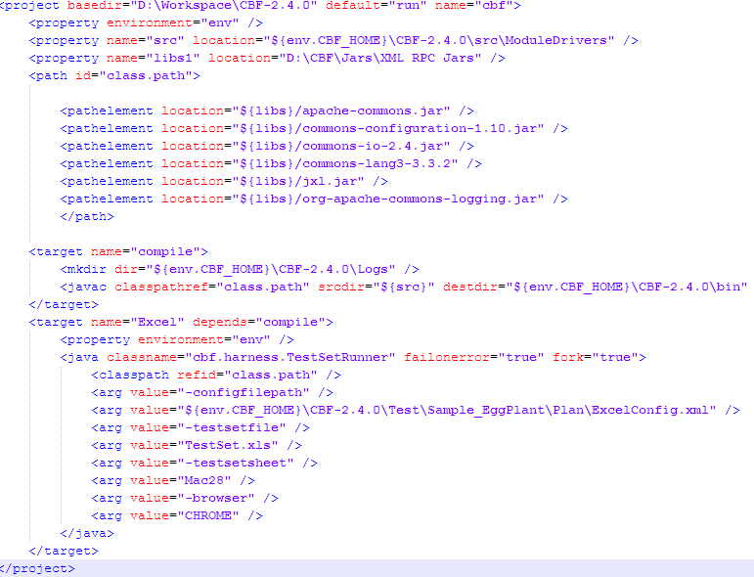

**Step 7 :**Execute ANT file directly by opening the command prompt from the folder and typing the command “**ant**” or by creating a “**bat**” file for the ant and executing it by double-click.

Command for bat file is as below, where “D:\CBF_ANT_Example” is project folder.

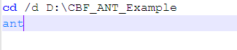

Arguments can also be passed directly from the command prompt.

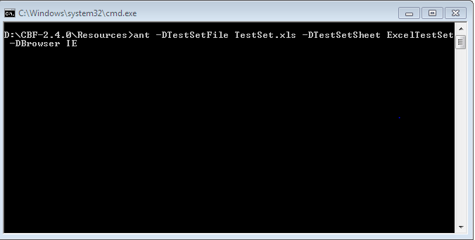

## Execution Results

*Once the execution of the test scripts is over, it’s now time to review the results. The results will be displayed as either Passed or Failed in the Test Summary Report.*

Test cases which are marked as Failed should be re – executed.

**Note:**

1. Rename the existing Log Folder in the C Drive with a logical name e.g. “First Run”, “Second Run” and so on (This is to ensure that you have the artifacts for all the executions)
2. Also ensure that all the data dependent test cases are supplied with the necessary data.

Step 1:Update the SelectYN column in TestSet.xls to Y for failed test cases and run the test set.

SummaryReport.xls – Summarized excel showing the status of all the test cases and steps executed in this batch.

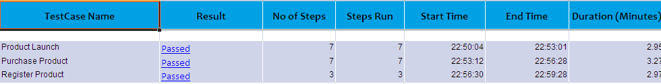

HTMLReport—Contains the testset summary and testcase summary.

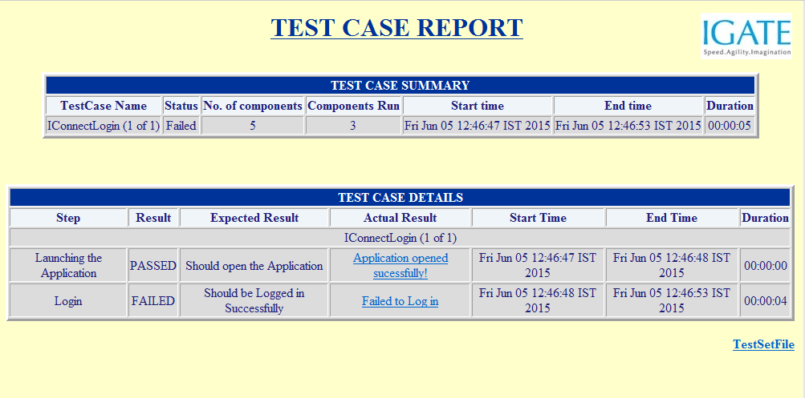

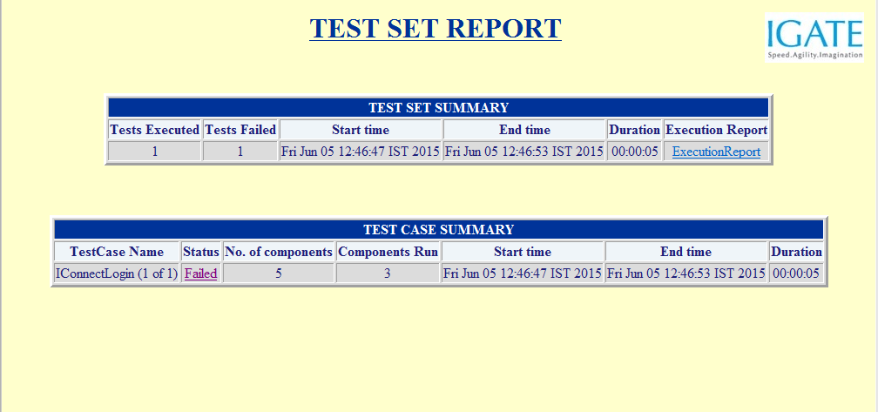

## Troubleshooting and debugging

## Steps to generate Javadoc

**Step1:** Select the project from Eclipse for which you want to generate Javadoc.

**Step2:** From the top panel of Eclipse, click **Project tab,** inside that select **Generate Javadoc** option.

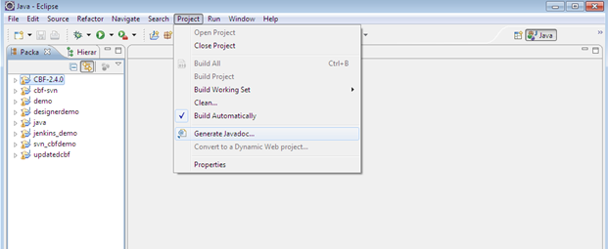

After selecting, the below window will appear :

**Step 3 :**Select all the files for which you want Javadoc and then given the proper path for the document to be created.

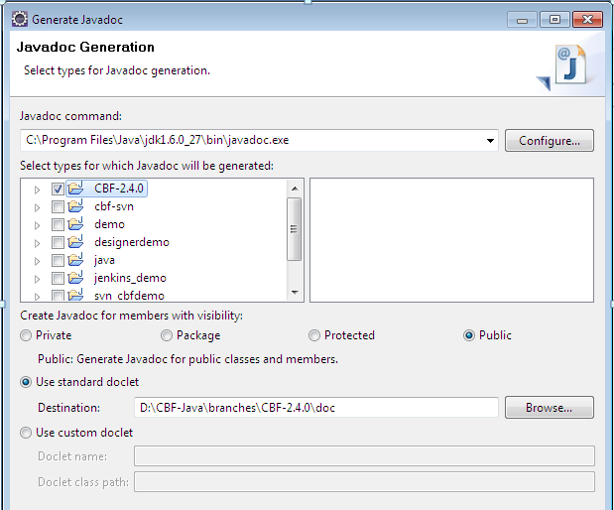

Follow the next steps and finish the document generation.

# DevelopmentManual

## API user guide

## Methodology &process

## Debugging & troubleshooting

# Maintenance Manual

## Framework testing, debugging and troubleshooting